Kobi Eini 201553245,
Moshe Dahan 203509229

Before running, make sure that you run these commends on your terminal:
a) sudo apt update
b) sudo apt install build-essential
c) sudo apt-get install libreadline-dev

The first two are for general updates of linux, needed for running our program.
The last one installs the libreadline library used by out shell.

To run out shell do the followings:
1) Extract shell_201553245_203509229 from the zip file, to a place of your choice.
2) Open a terminal in the current directory.
3) Run the next line in the terminal - to compile the project:
gcc -Wall main.c LinkList_MK.c -o shell_201553245_203509229 -lreadline
4) Run the next line in the terminal – to run the shell:
./shell_201553245_203509229

you will get the following screen:

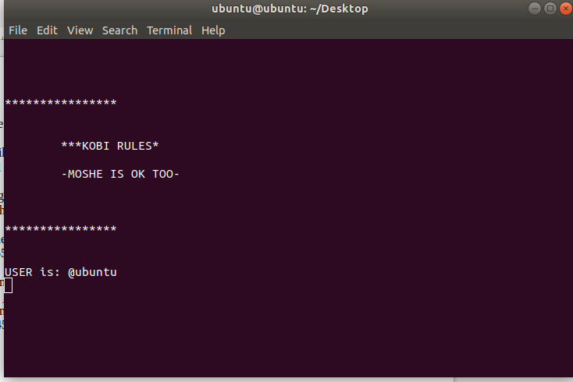

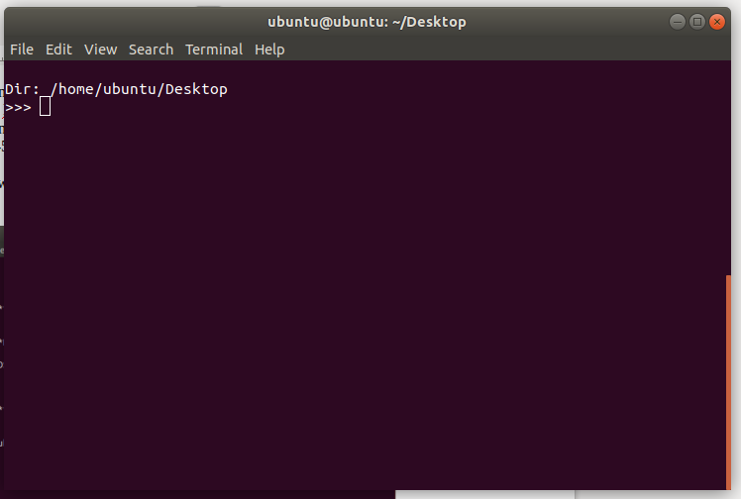

by entering the word: “help” you will be shown all the built in functions of the shell with the required syntax to use and examples:
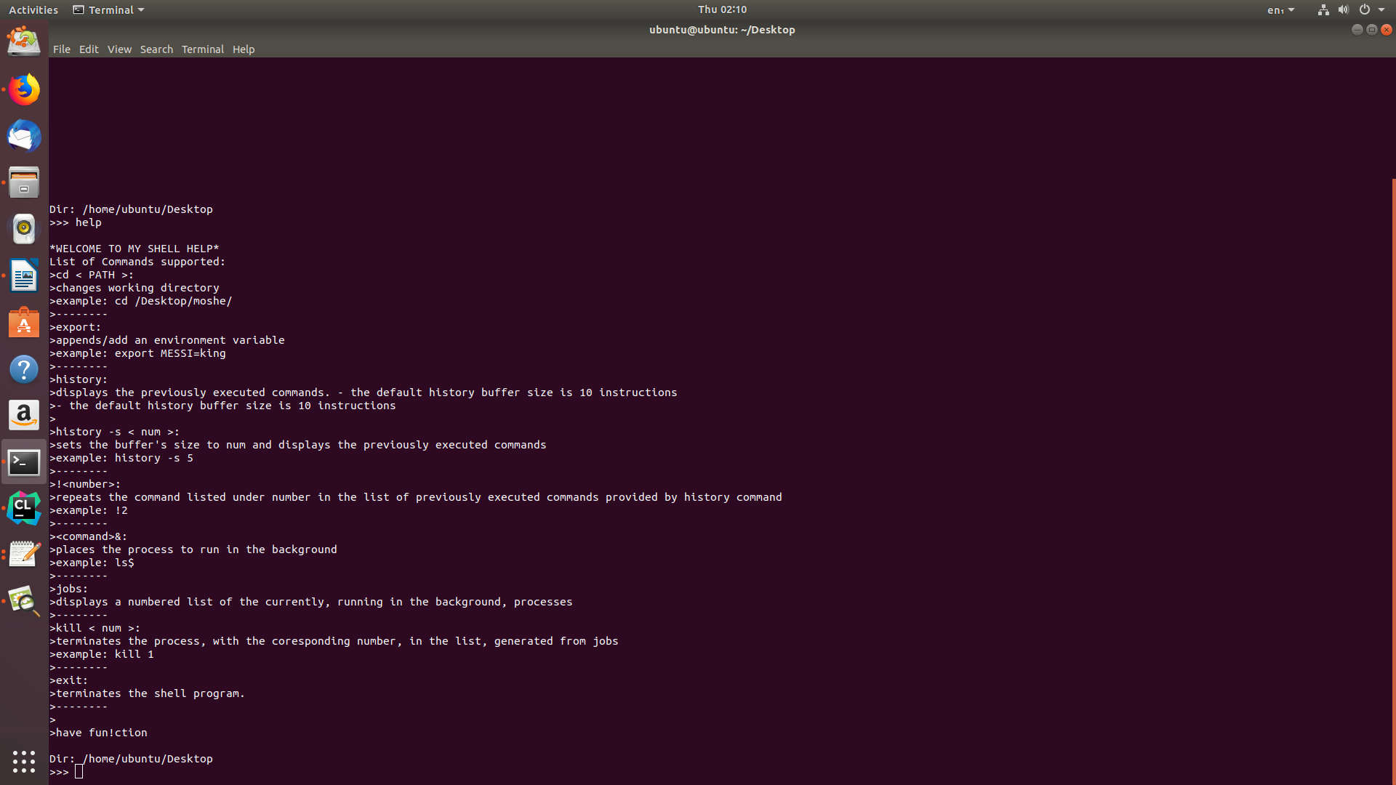
The cd + path will change the current directory.
Use ls command to see the files in the current directory.
Use pwd to see the current directory.
Use the export function to set an environment variable, and $VAR to reference it.
Use history command to look at previous executed commands, and use the flag -s followed by a number to change the size of the history buffer.
Use <number>1 to re - execute old command from the history table.
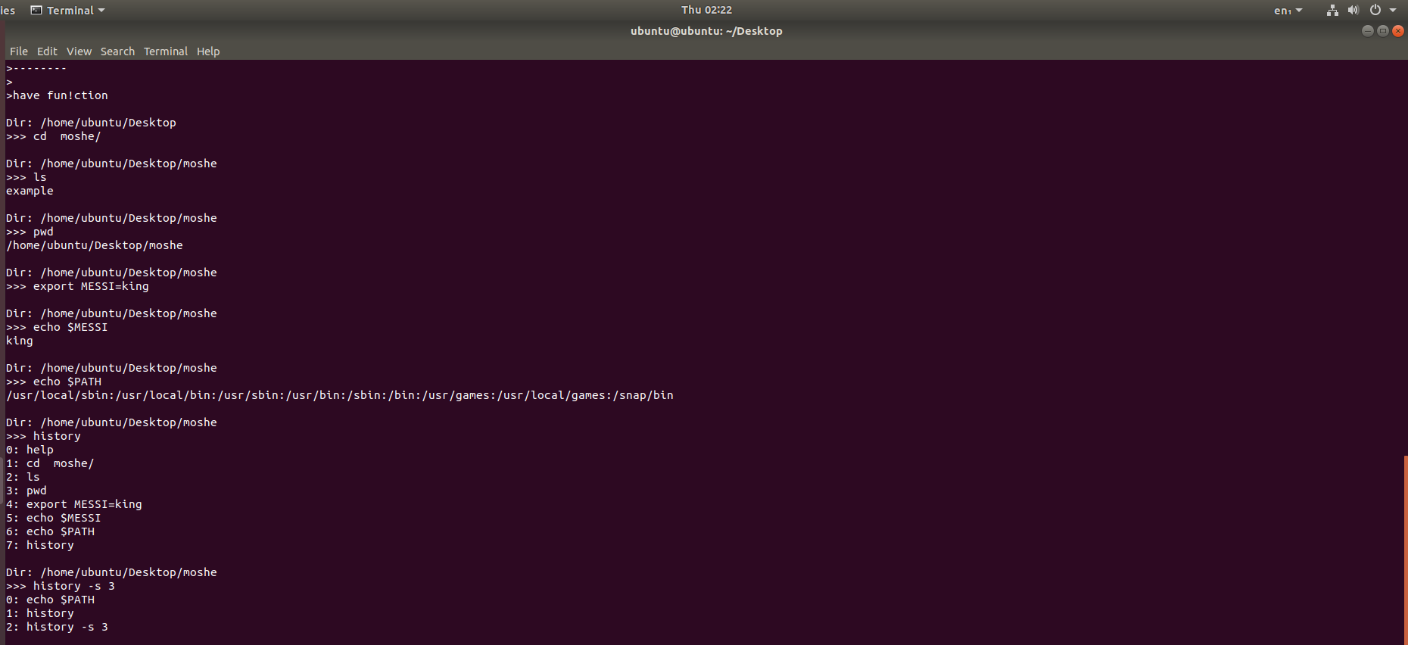

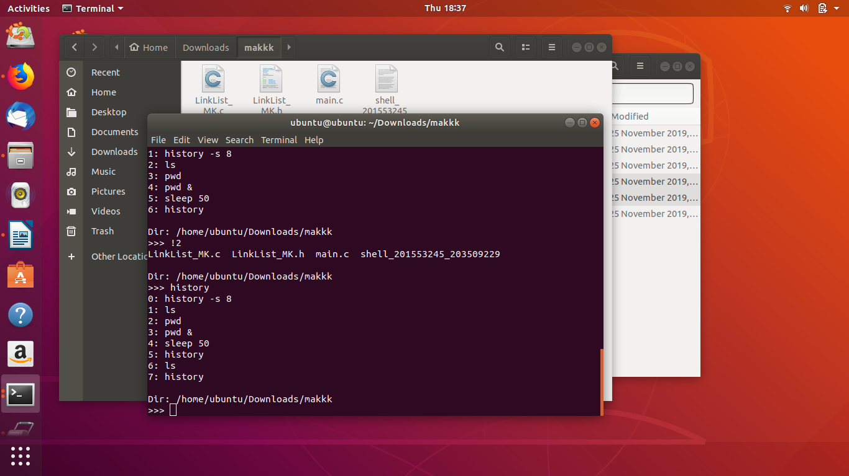

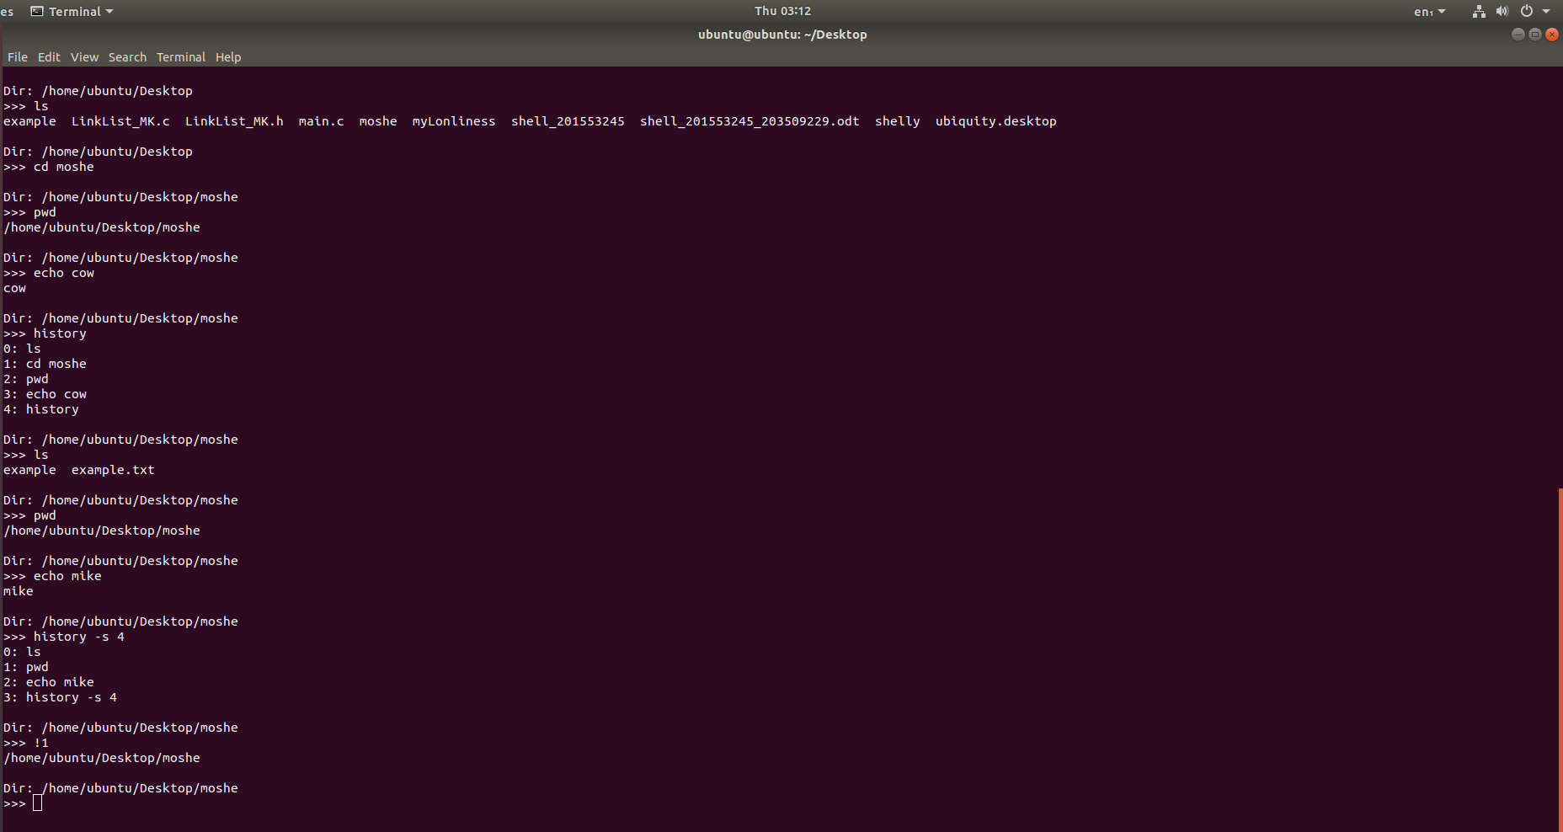

The shell also supports piped commands and “stdin” and “stdout” references by “<” and “>”.
The “<”, ”>” can also be used to create a new text file in the current directory.
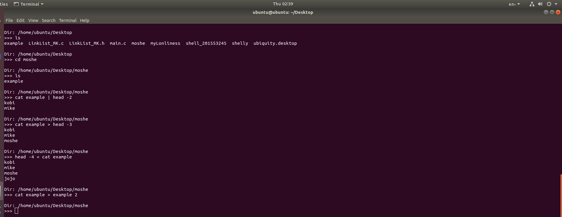
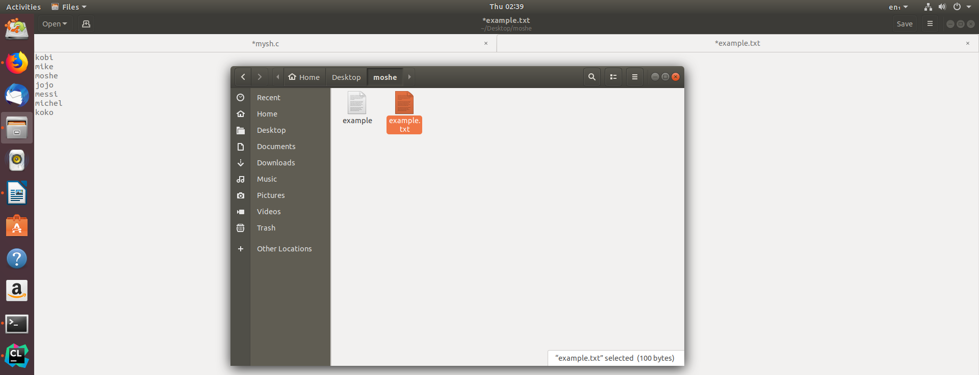

By adding the “&” at the end of the line the command typed will be executed in the background.
You can use “jobs” command to follow the running background processes, and “kill <number>” to kill a background process from the list.
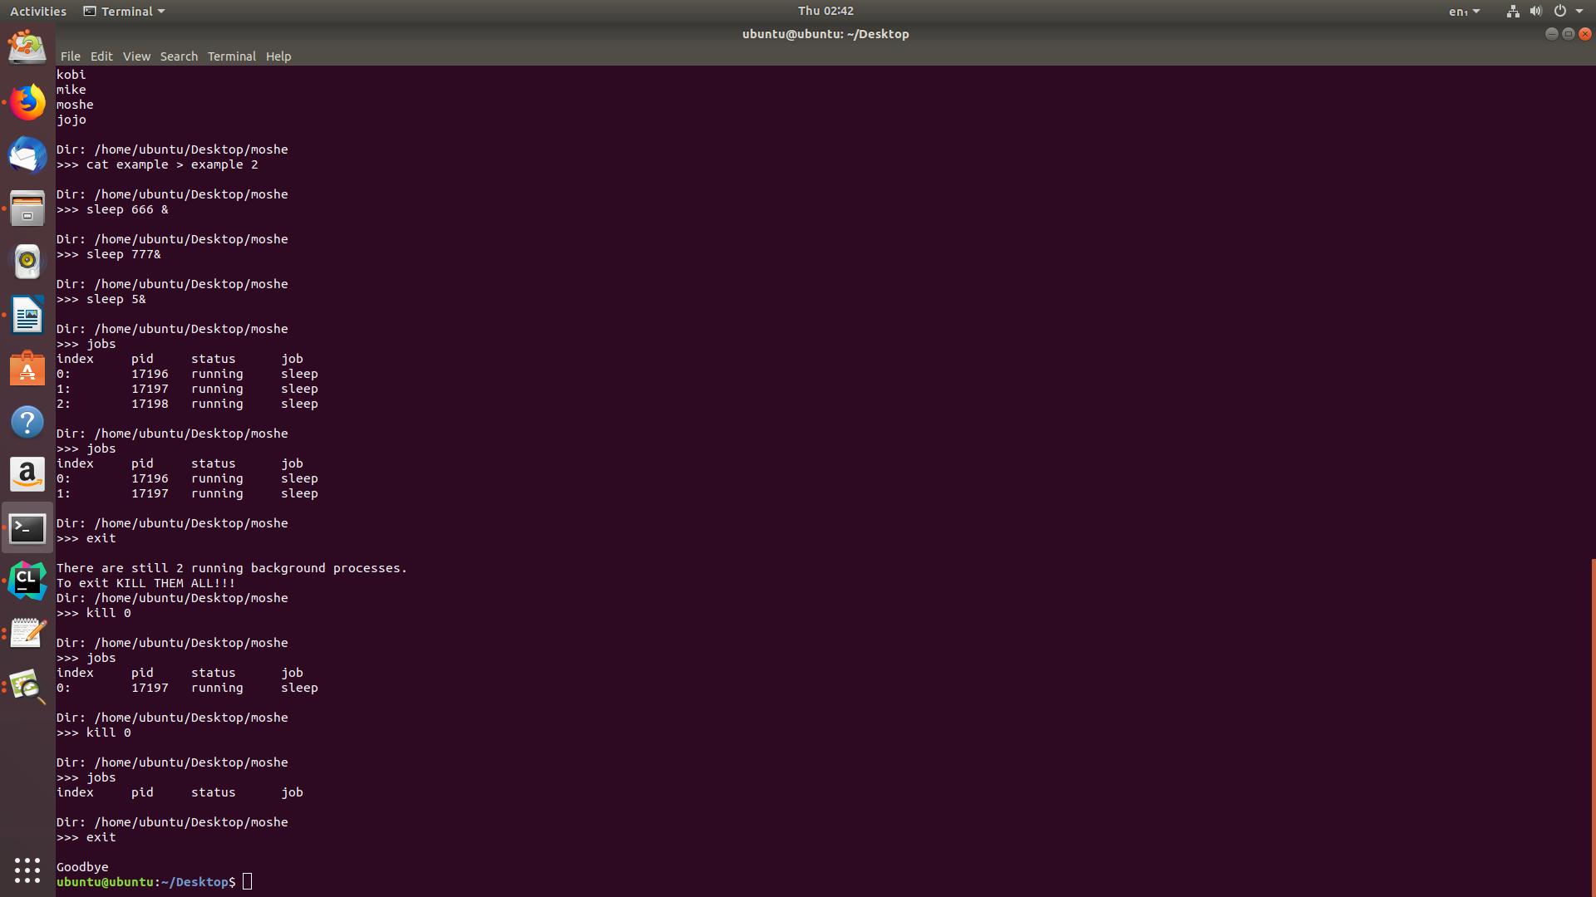
The “exit” will exit the shell, but only after all the background processes are done or killed.

* in our project we used parts of shell logic in the open source code in the following link:
https://www.geeksforgeeks.org/making-linux-shell-c/

